UNIT - VI

Parse tree (Derivation tree)
- A parse tree is an entity which represents the structure of the derivation of a terminal string from some non-terminal (not necessarily the start symbol)
- The process of deriving a string is called as derivation.
- The geometrical representation of a derivation is called as a parse tree or derivation tree.
- In parsing, the string is derived using the start symbol. The root of the parse tree is that start symbol..

The parse tree follows these points:
- The root of the parse tree is that start symbol.
- All leaf nodes have to be terminals.
- All interior nodes have to be non-terminals.

Example:
Production rules:
- S -> S + S | S * S
- S -> a|b|c
Input:
a * b + c

Derivation: S -> S + S ( Substitute S -> S * S )
S -> S * S + S ( Substitute S -> a )
S -> a * S + S ( Substitute S -> b )
S -> a * b + S ( Substitute S -> c )
S -> a * b + c

Input string S= a * b + c

Parse tree for the above input string

Step 1: S->S + S
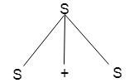

Step 2: S-> S * S + S
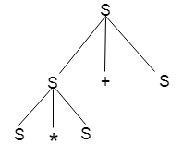

Step 3: S-> a * S + S
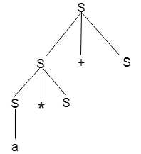

Step 4: S->a * b + S
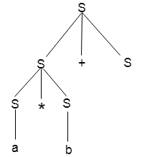

Step 5: S-> a * b + c
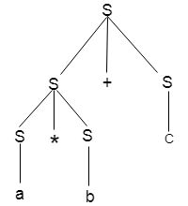

Example:
Construct parse tree for E --> E + E / E * E / id
Input string: id+ id* id
Derivation:
E --> E + E ( Substitute E --> E * E)
E --> E + E * E ( Substitute E --> id)
E --> id + E * E ( Substitute E --> id)
E --> id + id * E ( Substitute E --> id)
E --> id + id * id

Parse tree
Step1: E --> E + E

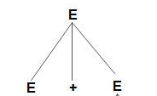
Step2: E --> E + E * E

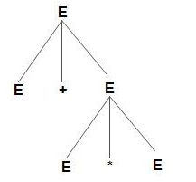

Step3: E --> id + E * E
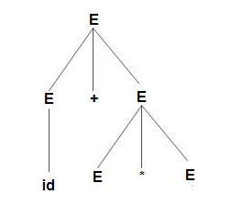
Step 4: E --> id + id * E
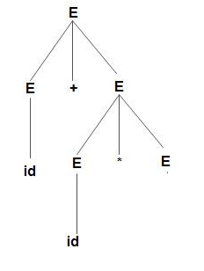
Step 5: E --> id + id * id
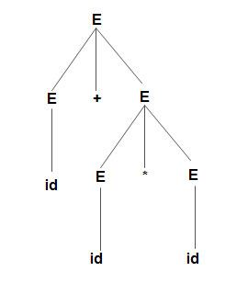
Example:
Construct parse tree for S --> SS* / SS+ / a
Input string aa +a* (construct the following diagram stepswise)

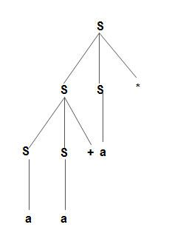
Top down parsing and bottom up parsing
A parser takes input in the form of sequence of tokens and produces output in the form of parse tree.
Parsing is of two types: Top down parsing and bottom up parsing.
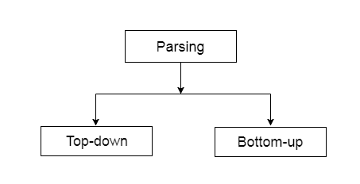

Top down paring
- The top down parsing is known as recursive parsing or predictive parsing.
- In the top down parsing, the parsing starts from the start symbol and transform it into the input symbol.

Example:
Production rules:
- S= S + S | S * S
- S = a | b | c
Input string: a * b + c
Top down Parsing: S=S + S ( Substitute S= S * S )
S= S * S + S ( Substitute S= a )
S= a * S + S ( Substitute S= b )
S= a * b + S ( Substitute S= c )
S= a * b + c ( Substitute S= b )

Top down Parse tree for the above input string

Step 1: S=S + S

Step 2: S= S * S + S

Step 3: S= a * S + S

Step 4: S= a * b + S

Step 5: S= a * b + c

Example
Let a CFG {N,T,P,S} be
N = {S}, T = {a, b}, Starting symbol = S,
P = S → SS | aSb | ε
Construct top down parsing for “abaabb”
Top down parsing is:
S → SS ( substitute S → aSb )
→ aSbS ( substitute S → ε )
→ abS ( substitute S → aSb )
→ abaSb ( substitute S → aSb )
→ abaaSbb ( substitute S → aSb )
→ abaabb (input sting)

Parse tree is: (construct the following tree stepswise)

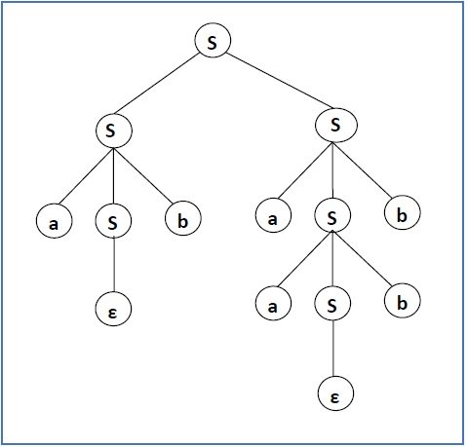

Example :
S → rXd | rZd
X → oa | ea
Z → ai
For an input string: read
a top-down parser, will behave like this:
S → rXd
S → read

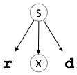 | 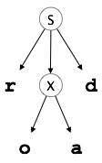 |  | 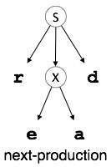

Bottom up parsing
- Bottom up parsing is also known as shift-reduce parsing.
- Bottom up parsing is used to construct a parse tree for an input string.
- In the bottom up parsing, the parsing starts with the input symbol and construct the parse tree up to the start symbol by tracing out the rightmost derivations of string in reverse.

Example
Productions
- E → T
- T → T * F
- T → id
- T → F
- F → id
Bottom up Parse Tree representation of input string "id * id" is as follows:

id * id → id * id
→ F * id
  - T * id
  - T * F
  - T
  - E

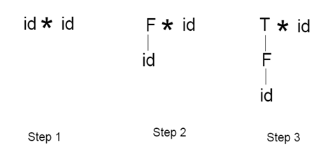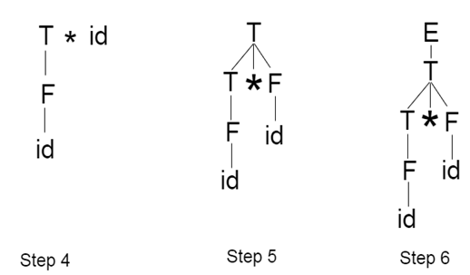

Example:
Input string : a + b * c
Production rules:
S → E
E → E + T
E → E * T
E → T
T → a/b/c
Let us start bottom-up parsing
a + b * c
Read the input and check if any production matches with the input:
a + b * c
→T + b * c
→E + b * c
→E + T * c
→E * c
→E * T
→E
→S

Step1: a + b * c

Step 2: T + b * c
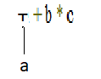
Step 3: E + b * c
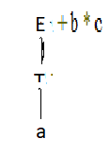
Step 4: E + T * c
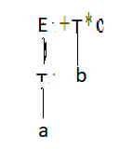
Step 5: E * c
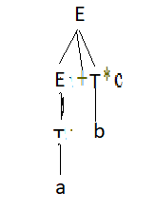
Step 6: E * T
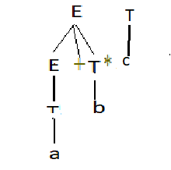
Step 7: E
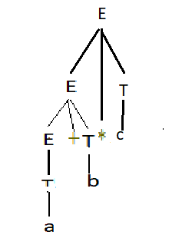
Step 8: S
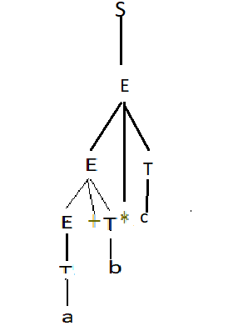

Types of context free grammar’s
- If CFG is generating finite number of strings, then CFG is Non-Recursive (or the grammar is said to be Non-recursive grammar)
- If CFG can generate infinite number of strings then the grammar is said to be Recursive grammar.

Examples of Recursive and Non-Recursive Grammars
Recursive Grammars
1) S->SaS
S->b
The language(set of strings) generated by the above grammar is :{b, bab, babab,…}, which is infinite.
2) S-> Aa
A->Ab|c
The language generated by the above grammar is :{ca, cba, cbba …}, which is infinite.
Note: A recursive context-free grammar that contains no useless rules necessarily produces an infinite language.

Non-Recursive Grammars
S->Aa
A->b|c
The language generated by the above grammar is :{ba, ca}, which is finite.
Types of CFG Recursive Grammars
Based on the nature of the recursion in a recursive grammar, a recursive CFG can be again divided into the following:
- Left Recursive Grammar (having left Recursion)
- Right Recursive Grammar (having right Recursion)

Left Recursive Grammars
In a context-free grammar G, if there is a production in the form X → Xa where X is a non-terminal and ‘a’ is a string of terminals, it is called a left recursive production. The grammar having a left recursive production is called a left recursive grammar.

Right Recursive Grammars
And if in a context-free grammar G, if there is a production is in the form X → aX where X is a non-terminal and ‘a’ is a string of terminals, it is called a right recursive production. The grammar having a right recursive production is called a right recursive grammar.

Types of Derivation Tree
There are three types of Derivation trees;
- Leftmost Derivation tree
- Rightmost derivation tree
- Mixed derivation tree

1. Leftmost Derivation-
- The process of deriving a string by expanding the leftmost non-terminal at each step is called as leftmost derivation.
- The geometrical representation of leftmost derivation is called as a leftmost derivation tree.
Example:
Consider the grammar G with production:
S → aSS (Rule: 1)
S → b (Rule: 2)
Compute the string w = ‘aababbb’ with left most derivation.
S ⇒ aSS (Rule: 1)
⇒ aaSSS (Rule: 1)
⇒ aabSS (Rule: 2)
⇒ aabaSSS (Rule: 1)
⇒ aababSS (Rule: 2)
⇒ aababbS (Rule: 2)
⇒ aababbb (Rule: 2)

Example-

Consider the following grammar-
S → aB / bA
A → aS / bAA / a
B → bS / aBB / b

Let us consider a string w = aaabbabbba
Now, let us derive the string w using leftmost derivation.
Leftmost Derivation-
S → aB
→ aaBB (Using B → aBB)
→ aaaBBB (Using B → aBB)
→ aaabBB (Using B → b)
→ aaabbB (Using B → b)
→ aaabbaBB (Using B → aBB)
→ aaabbabB (Using B → b)
→ aaabbabbS (Using B → bS)
→ aaabbabbbA (Using S → bA)
→ aaabbabbba (Using A → a)

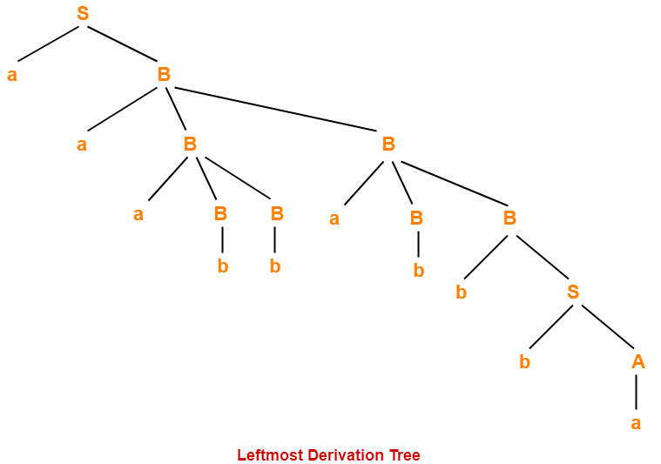

2. Rightmost Derivation-
- The process of deriving a string by expanding the rightmost non-terminal at each step is called as rightmost derivation.
- The geometrical representation of rightmost derivation is called as a rightmost derivation tree.

Example-
Consider the following grammar-
S → aB / bA
S → aS / bAA / a
B → bS / aBB / b
Let us consider a string w = aaabbabbba
Now, let us derive the string w using rightmost derivation.
Rightmost Derivation-
S → aB
→ aaBB (Using B → aBB)
→ aaBaBB (Using B → aBB)
→ aaBaBbS (Using B → bS)
→ aaBaBbbA (Using S → bA)
→ aaBaBbba (Using A → a)
→ aaBabbba (Using B → b)
→ aaaBBabbba (Using B → aBB)
→ aaaBbabbba (Using B → b)
→ aaabbabbba (Using B → b)

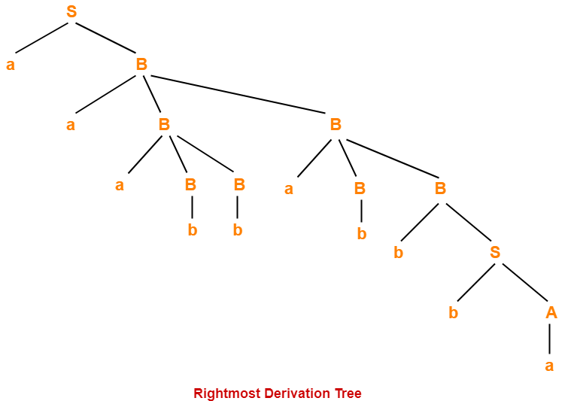

Example:
Consider the grammar G with production:
S → aSS (Rule: 1)
S → b (Rule: 2)
Compute the string w = ‘aababbb’ with right most derivation.
S ⇒ aSS (Rule: 1)
⇒ aSb (Rule: 2)
⇒ aaSSb (Rule: 1)
⇒ aaSaSSb (Rule: 1)
⇒ aaSaSbb (Rule: 2)
⇒ aaSabbb (Rule: 2)
⇒ aababbb (Rule: 2)
Mixed Derivation: In a mixed derivation the string is obtained by applying production to the leftmost variable and rightmost variable simultaneously as per the requirement in each successive step.
S → aAB (Rule: 1)
A → Bba (Rule: 2)
B → bB (Rule: 3)
B → c (Rule: 4)
Compute the string w = ‘acbabc’ with left most derivation.
S ⇒ aAB (Rule: 1)
⇒ aBbaB (Rule: 2)
⇒ acbaB (Rule: 4)
⇒ acbabB (Rule: 3)
⇒ acbabc (Rule: 4)
Left most derivation Tree to obtain the string w = ‘acbabc’ as follows;
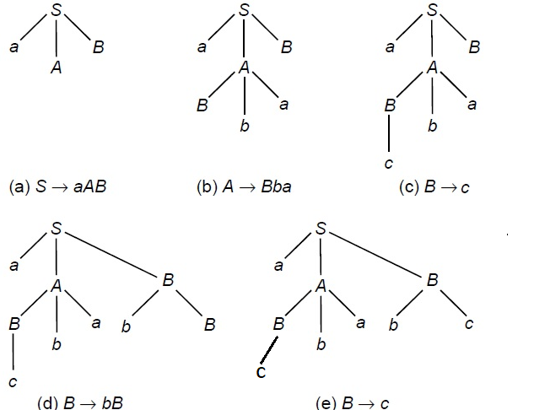

Example 2: A grammar G which is context-free has the productions.
S → a (Rule: 1)
S → aAS (Rule: 2)
A → bS (Rule: 3)
Compute the string w = ‘abaabaa’ with left most derivation.
S ⇒ aAS (Rule: 2)
⇒ abSS (Rule: 3)
⇒ abaS (Rule: 1)
⇒ abaaAS (Rule: 2)
⇒ abaabSS (Rule: 3)
⇒ abaabaS (Rule: 1)
⇒ abaabaa (Rule: 1)
Left most derivation Tree to obtain the string ‘w’ as follows;
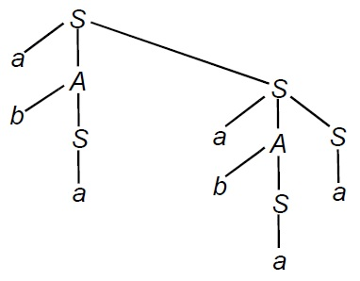
Example 3: A grammar G = (N, T, P, S) with N = {E}, S = E, T = {id, +, *, c}
E → E + E (Rule: 1)
E → E * E (Rule: 2)
E → ( E ) (Rule: 3)
E → id (Rule: 4)
Obtain the left derivation tree of expressions:
(i) id * id + id
(ii) id + id * id
Solution:
(i)
E ⇒ E + E (Rule: 1)
⇒ E * E + E (Rule: 2 and left derivation)
⇒ id * id + id (Rule: 4 and left derivation)
Derivation tree is
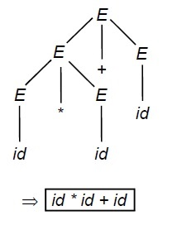
(ii)
E ⇒ E * E (Rule: 2)
⇒ ( E ) * E (Rule: 3 and left derivation)
⇒ ( E + E ) * E (Rule: 1 and left derivation)
⇒ ( id + id ) * id (Rule: 4)
Derivation tree is
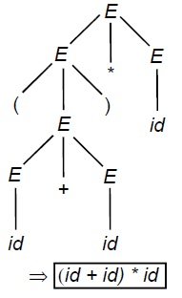
Example 4: A grammar G = (N, T, P, S) with N = {S, A}, T = {a, b} and P are as follow;
S → aS (Rule: 1)
S → aA (Rule: 2)
A → bA (Rule: 3)
A → b (Rule: 4)
Obtain the derivation tree and L(G)( Language of the above grammar).
Solution:
(i) S ⇒ aA (Rule: 2)
⇒ ab (Rule: 4)
(ii) S ⇒ aS (Rule: 1)
⇒ aaA (Rule: 3)
⇒ aab (Rule: 4)
(iii) S ⇒ aS (Rule: 1)
⇒ aaS (Rule: 1)
⇒ aaaA (Rule: 3)
⇒ aaab (Rule: 4)
(iv) S ⇒ aS (Rule: 1)
⇒ aaS (Rule: 1)
⇒ aabA (Rule: 3)
⇒ aabb (Rule: 4)
(v) S ⇒ aS (Rule: 1)
⇒ aaS (Rule: 1)
⇒ aaaS (Rule: 1)
⇒ aaaaA (Rule: 3)
⇒ aaaab (Rule: 4)
Hence; Language generated by the above grammar L(G) = { ab, aab, aaab, aabb, aaaab, .. .. .. ..}
Thus we can write the language of the grammar L(G) = {a^{n} b^{m} : n > 0 ; m > 0}
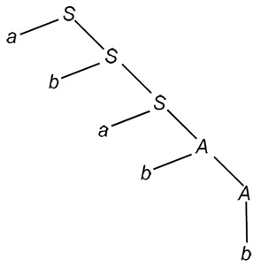
PRACTICE PROBLEMS BASED ON Derivations, Parse Tree- Leftmost Derivation And Rightmost Derivation
EXAMPLE:
Draw a derivation tree for the string "bab" from the CFG given by
- S → bSb | a | b
Solution:
Now, the derivation tree for the string "bbabb" is as follows:
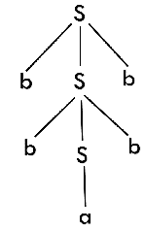
The above tree is a derivation tree drawn for deriving a string bbabb. By simply reading the leaf nodes, we can obtain the desired string.

Example :
Construct a derivation tree for the string aabbabba for the CFG given by,
- S → aB | bA
- A → a | aS | bAA
- B → b | bS | aBB
Solution:
To draw a tree, we will first try to obtain derivation for the string aabbabba
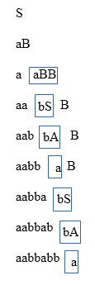
Now, the derivation tree is as follows:
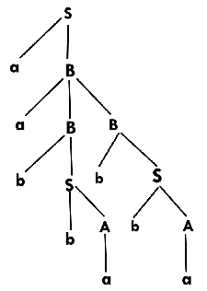

Example :
Show the derivation tree for string "aabbbb" with the following grammar.
- S → AB | ε
- A → aB
- B → Sb
Solution:
To draw a tree we will first try to obtain derivation for the string aabbbb
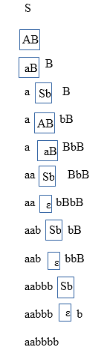
Now, the derivation tree for the string "aabbbb" is as follows:

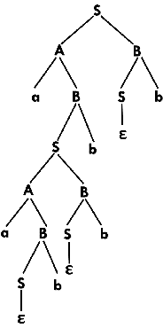

Problem-01:

Consider the grammar-
S → bB / aA
A → b / bS / aAA
B → a / aS / bBB

For the string w = bbaababa, find-
- Leftmost derivation
- Rightmost derivation
- Parse Tree

Solution-

1. Leftmost Derivation-

S → bB
→ bbBB (Using B → bBB)
→ bbaB (Using B → a)
→ bbaaS (Using B → aS)
→ bbaabB (Using S → bB)
→ bbaabaS (Using B → aS)
→ bbaababB (Using S → bB)
→ bbaababa (Using B → a)

2. Rightmost Derivation-

S → bB
→ bbBB (Using B → bBB)
→ bbBaS (Using B → aS)
→ bbBabB (Using S → bB)
→ bbBabaS (Using B → aS)
→ bbBababB (Using S → bB)
→ bbBababa (Using B → a)
→ bbaababa (Using B → a)

3. Parse Tree-
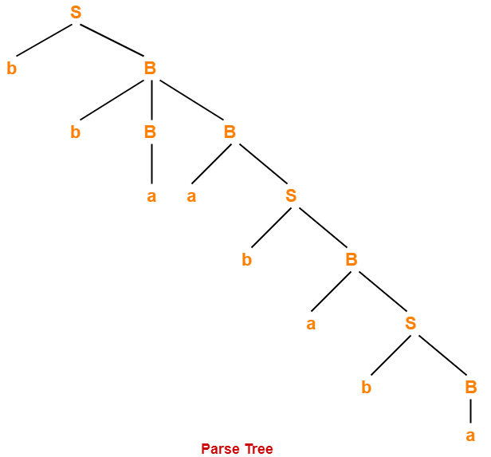

Problem-02:
Consider the grammar-
S → A1B
A → 0A / ∈
B → 0B / 1B / ∈

For the string w = 00101, find-
- Leftmost derivation
- Rightmost derivation
- Parse Tree

Solution-

1. Leftmost Derivation-

S → A1B
→ 0A1B (Using A → 0A)
→ 00A1B (Using A → 0A)
→ 001B (Using A → ∈)
→ 0010B (Using B → 0B)
→ 00101B (Using B → 1B)
→ 00101 (Using B → ∈)

2. Rightmost Derivation-
S → A1B
→ A10B (Using B → 0B)
→ A101B (Using B → 1B)
→ A101 (Using B → ∈)
→ 0A101 (Using A → 0A)
→ 00A101 (Using A → 0A)
→ 00101 (Using A → ∈)

3. Parse Tree-
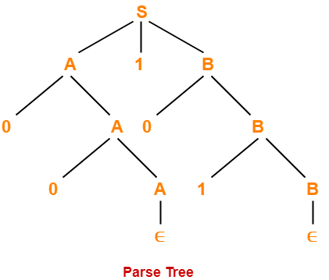

Simplification of CFG: or ( Optimization of CFG)or (Reduction of CFG)
In a CFG, it may happen that all the production rules and symbols are not needed for the derivation of strings. Besides, there may be some null productions and unit productions. Elimination of these productions and symbols is called simplification of CFGs. Simplification essentially comprises of the following steps −
- Reduction of Removal of Useless Symbols
- Removal of Unit Productions
- Removal of Null Productions

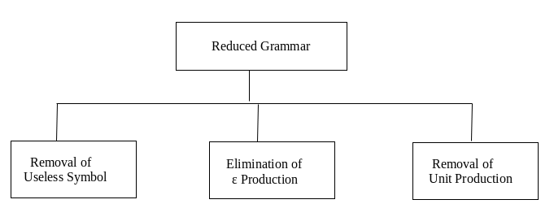

Removal of Useless Symbols
A symbol can be useless if it does not appear on the right-hand side of the production rule and does not take part in the derivation of any string. That symbol is known as a useless symbol. Similarly, a variable can be useless if it does not take part in the derivation of any string. That variable is known as a useless variable.

For Example:
- T → aaB | abA | aaT
- A → aA
- B → ab | b
- C → ad
In the above example, the variable 'C' will never occur in the derivation of any string or never occur in right side of productions. so the production C → ad is useless.
So we will eliminate it, and the other productions are written in such a way that variable C can never reach from the starting variable 'T'.
Production A → aA is also useless because there is no way to terminate it. If it never terminates, then it can never produce a string. Hence this production can never take part in any derivation.
To remove this useless production A → aA and T→ abA, this lead to unterminated string
After removing
T → aaB | aaT
B → ab | b

Example:
S -> abS | abA | abB
A -> cd
B -> aB
C -> dc
In the example above ,
Eliminate production ‘C -> dc’ is useless because the variable ‘C’ will never occur in derivation of any string.
Eliminate Production ‘B ->aB’ and S → abB are also useless because there is no way it will ever terminate . If it never terminates , then it can never produce a string.
So the modified grammar becomes –
S -> abS | abA
A -> cd
Example:
S -> AB/a
A -> BC/b
B -> aB/C
C -> aC/B

Solution: Eliminate S -> AB, A -> BC, B -> aB/C, C -> aC/B (these are lead to unterminated strings). After removing
S -> a
A -> b

remove A -> b because useless production

S -> a

Example:
S -> AB/AC
A -> aAb/bAa/a
B -> bbA/aaB/AB
C -> abCA/aDb
D -> bD/aC

Solution:
S -> AB
A -> aAb/bAa/a
B -> bbA/aaB/AB

Elimination of ε Production
Null productions are of the form A -> ϵ.
In this remove the null productions from the grammar. We cannot remove all ϵ-productions from a grammar if the language contains ϵ as a word, but if it doesn’t we can remove all.
The productions of type S → ε are called ε productions. These type of productions can only be removed from those grammars that do not generate ε.
Step 1: First find out all nullable non-terminal variable which derives ε.
Step 2: For each production A → a, construct all production A → x, where x is obtained from a by removing one or more non-terminal from step 1.
Step 3: Now combine the result of step 2 with the original production and remove ε productions.

Example:
Remove the ε production from the following CFG
- S → XYX
- X → 0X | ε
- Y → 1Y | ε
Solution:
Now, while removing ε production, we are deleting the rule X → ε and Y → ε.
To preserve the meaning of CFG we are actually placing ε at the right-hand side whenever X and Y have appeared.
Let us take
S → XYX
Substitute ε in first X at right-hand side. Then
S → YX
Similarly Substitute ε in last X. Then
S → XY
Substitute ε in Y then
S → XX
If Y and X are ε then,
S → X
If both X are replaced by ε
S → Y
Now, Combine original production and remove ε productions
S → XYX |XY | YX | XX | X | Y
Now let us consider
X → 0X
Substitute ε at right-hand side for X then,
X → 0
Combine original production and remove ε productions
X → 0
X → 0X | 0
Now let us consider
Y → 1Y
Substitute ε at right-hand side for Y then,
Y→ 1
Combine original production and remove ε productions
Y→ 1
Y → 1Y | 1
Collectively we can rewrite the CFG with removed ε production as
S → XYX |XY | YX | XX | X | Y
X → 0X | 0
Y → 1Y | 1

Problem
Remove null production from the following −
S → ASA | aB | b,
A → B
B → b | ∈
Solution −
There are two nullable variables − A and B
A → B
B → b | ∈
we will remove B → ε.
S → ASA | aB | b (substitute B→ ε) then
S→ASA | a | b
Combine original production and remove ε productions
S→ASA | aB | b | a
Consider A → B (substitute B→ ε) then
A→ ε

Combine original production and remove ε productions
A → B | ε

After removing B → ε, the production set becomes −
S→ASA | aB | b | a
A → B | ε
B → b

Now we will remove A → ε.
Consider S→ASA | aB | b | a (substitute A→ ε) then
S→ SA | AS | S | aB | b | a |
Combine original production and remove ε productions
S→ASA | aB | b | a | SA | AS | S
After removing A → ε, the production set becomes –

S→ASA | aB | b | a | SA | AS | S
A → B
B → b
This is the final production set without null transition.

Example: Remove the null productions from the following grammar
S -> ABAC
A -> aA / ϵ
B -> bB / ϵ
C -> c
Solution:
We have two null productions in the grammar A -> ϵ and B -> ϵ.
To eliminate A -> ϵ we have to change the productions containing A in the right side. Those productions are

S -> ABAC
A -> aA.
So replacing each occurrence of A by ϵ, we get four new productions
S -> ABC / BAC / BC
A -> a
Add these productions to the grammar and eliminate A -> ϵ.
S -> ABAC / ABC / BAC / BC
A -> aA / a
B -> bB / ϵ
C -> c
To eliminate B -> ϵ we have to change the productions containing B on the right side. Doing that we generate these new productions:
S -> AAC / AC / C
B -> b
Add these productions to the grammar and remove the production B -> ϵ from the grammar. The new grammar after removal of ϵ – productions is:
S -> ABAC / ABC / BAC / BC / AAC / AC / C
A -> aA / a
B -> bB / b
C -> c

Removing Unit Productions

The productions of type ‘A -> B’ are called unit productions.

The unit productions are the productions in which one non-terminal gives another non-terminal (X→ Y). Use the following steps to remove unit production:
Step 1: To remove X → Y, add production X → a to the grammar rule whenever Y → a occurs in the grammar.
Step 2: Now delete X → Y from the grammar.
Step 3: Repeat step 1 and step 2 until all unit productions are removed.

For example:
- S → 0A | 1B | C
- A → 0S | 00
- B → 1 | A
- C → 01
Solution:
S → C is a unit production. But while removing S → C we have to consider what C gives. So, we can add a rule to S.
Substitute C → 01 in S production
S → 0A | 1B | 01
Similarly, B → A is also a unit production so we can modify it as
Substitute A → 0S | 00 in B production
B → 1 | 0S | 00
Thus finally we can write CFG without unit production as
S → 0A | 1B | 01
A → 0S | 00
B → 1 | 0S | 00
C → 01
Example:
Given grammar is :
S -> Aa/B/c
B -> A/bb
A -> a/bc/B

Solution:
UNIT productions are
S→C, B→A and A→ B
Substitute B → bb in A production
A -> a/bc/bb
Substitute A → a|bc in B production
B -> a/bc /bb
Substitute B -> a/bc /bb in S production
S -> Aa/c/bb/a/bc
Finally after removing unit productions
B -> bb
S -> Aa/c/bb/a/bc
A -> a/bc

Example:
S -> AC
A -> a
C -> B/d
B -> D
D -> E
E -> b

Solution: Unit productions are
C -> B
B -> D
D -> E
Substitute E -> b in D production
D -> b
Substitute D -> b in B production
B -> b
Substitute B -> b in C production
C -> b/d (C -> B/d )
Finally
S -> AC
A -> a
C -> d/b
B -> b
D -> b
E -> b

Normal Forms of Context-Free Grammars
  - Chomsky Normal Form (CNF)
  - Greibach Normal Form (GNF)

- Chomsky's Normal Form (CNF)
CNF stands for Chomsky normal form. A CFG(context free grammar) is in CNF(Chomsky normal form) if all production rules satisfy one of the following conditions:
- Start symbol generating ε. For example, S → ε.
- A non-terminal generating two non-terminals. For example, A → AB.
- A non-terminal generating a terminal. For example, A → a.

For example:
- G1 = {S → AB, S → c, A → a, B → b} (G1 satisfy the rules specified for CNF)
- G2 = {S → aA, A → a, B → c} (G2 does not satisfy the rules specified for CNF )
The production rules of Grammar G1 satisfy the rules specified for CNF, so the grammar G1 is in CNF. However, the production rule of Grammar G2 does not satisfy the rules specified for CNF as S → aZ contains terminal followed by non-terminal. So the grammar G2 is not in CNF.

Steps for converting CFG into CNF
Step 1: Eliminate start symbol from the RHS. If the start symbol S is at the right-hand side of any production, create a new production as:
- S1 → S
Where S1 is the new start symbol.
Step 2: In the grammar, remove the null, unit and useless productions.
Step 3: Eliminate terminals from the RHS of the production if they exist with other non-terminals or terminals. For example, production S → aA can be decomposed as:
- S → RA (R=a)
- R → a
Step 4: Eliminate RHS with more than two non-terminals. For example, S → ASB can be decomposed as:
- S → RB (R=AS)
- R → AS

Example:
Convert the given CFG to CNF. Consider the given grammar G1:
- S → a | aA | B
- A → aBB | ε
- B → Aa | b
Solution:
Step 1: Start symbol S is not appears on the RHS. No need to create New symbol.The grammar will be:
- S → a | aA | B
- A → aBB | ε
- B → Aa | b
Step 2: As grammar G1 contains A → ε null production, its removal from the grammar yields:
- S → a | aA | B
- A → aBB
- B → Aa | b | a
Now, as grammar G1 contains Unit production S → B, its removal yield:
- S → a | aA | Aa | b
- A → aBB
- B → Aa | b | a
Step 3: In the production rule S → aA | Aa, A → aBB and B → Aa, terminal a exists on RHS with non-terminals. So we will replace terminal a with X:

- S → a | XA | AX | b
- A → XBB
- B → AX | b | a
- X → a
Step 4: In the production rule A → XBB, RHS has more than two symbols, removing it from grammar yield:
- S → a | XA | AX | b
- A → RB
- B → AX | b | a
- X → a
- R → XB
Hence, for the given grammar, this is the required CNF.
Finally the above grammar is in CNF.
Example – An example to convert CFG to CNF. Consider the given grammar
:
S → ASB
A → aAS|a|ε
B → SbS|A|bb

Step 1. As start symbol S appears on the RHS, we will create a new production rule
S0->S. Therefore, the grammar will become:

S0->S
S → ASB
A → aAS|a|ε
B → SbS|A|bb

Step 2. As grammar contains null production A-> ε, its removal from the grammar yields:
S0->S
S → ASB|SB
A → aAS|aS|a
B → SbS| A|ε|bb

Now, it creates null production B→ ε, its removal from the grammar yields:
S0->S
S → AS|ASB| SB| S
A → aAS|aS|a
B → SbS| A|bb

Now, it creates unit production B->A, its removal from the grammar yields:
S0->S
S → AS|ASB| SB| S
A → aAS|aS|a
B → SbS|bb|aAS|aS|a

Also, removal of unit production S0->S from grammar yields:
S0-> AS|ASB| SB| S
S → AS|ASB| SB| S
A → aAS|aS|a
B → SbS|bb|aAS|aS|a

Also, removal of unit production S->S and S0->S from grammar yields:
S0-> AS|ASB| SB
S → AS|ASB| SB
A → aAS|aS|a
B → SbS|bb|aAS|aS|a

Step 3. In production rule A->aAS |aS and B-> SbS|aAS|aS, terminals a and b exist on RHS with non-terminates. Removing them from RHS:

S0-> AS|ASB| SB
S → AS|ASB| SB
A → XAS|XS|a
B → SYS|bb|XAS|XS|a
X →a
Y→b

Also, B->bb can’t be part of CNF, removing it from grammar yields:
S0-> AS|ASB| SB
S → AS|ASB| SB
A → XAS|XS|a
B → SYS|VV|XAS|XS|a
X → a
Y → b
V → b

Step 4: In production rule S0->ASB, RHS has more than two symbols, removing it from grammar yields:
S0-> AS|PB| SB
S → AS|ASB| SB
A → XAS|XS|a
B → SYS|VV|XAS|XS|a
X → a
Y → b
V → b
P → AS

Similarly, S->ASB has more than two symbols, removing it from grammar yields:
S0-> AS|PB| SB
S → AS|QB| SB
A → XAS|XS|a
B → SYS|VV|XAS|XS|a
X → a
Y → b
V → b
P → AS
Q → AS

Similarly, A->XAS has more than two symbols, removing it from grammar yields:
S0-> AS|PB| SB
S → AS|QB| SB
A → RS|XS|a
B → SYS|VV|XAS|XS|a
X → a
Y → b
V → b
P → AS
Q → AS
R → XA

Similarly, B->SYS has more than two symbols, removing it from grammar yields:
S0 -> AS|PB| SB
S → AS|QB| SB
A → RS|XS|a
B → TS|VV|XAS|XS|a
X → a
Y → b
V → b
P → AS
Q → AS
R → XA
T → SY

Similarly, B->XAX has more than two symbols, removing it from grammar yields:
S0-> AS|PB| SB
S → AS|QB| SB
A → RS|XS|a
B → TS|VV|US|XS|a
X → a
Y → b
V → b
P → AS
Q → AS
R → XA
T → SY
U → XA

- Greibach Normal Form (GNF)
GNF stands for Greibach normal form. A CFG(context free grammar) is in GNF(Greibach normal form) if all the production rules satisfy one of the following conditions:
- A start symbol generating ε. For example, S → ε.
- A non-terminal generating a terminal. For example, A → a.
- A non-terminal generating a terminal which is followed by any number of non-terminals. For example, S → aA, , S → aAS. , S → aASB.
For example:
- G1 = {S → aAB | aB, A → aA| a, B → bB | b}
- G2 = {S → aAB | aB, A → aA | ε, B → bB | ε}
The production rules of Grammar G1 satisfy the rules specified for GNF, so the grammar G1 is in GNF. However, the production rule of Grammar G2 does not satisfy the rules specified for GNF as A → ε and B → ε contains ε(only start symbol can generate ε). So the grammar G2 is not in GNF.

Steps for converting CFG into GNF
Step 1: Convert the grammar into CNF.
If the given grammar is not in CNF, convert it into CNF. You can refer the following topic to convert the CFG into CNF: Chomsky normal form
Step 2: If the grammar exists left recursion, eliminate it.
If the context free grammar contains left recursion, eliminate it.
Step 3: In the grammar, convert the given production rule into GNF form.
If any production rule in the grammar is not in GNF form, convert it.

Example: conversion from CFG to GNF
- S → XB | AA
- A → a | SA
- B → b
- X → a
Solution:
As the given grammar G is already in CNF and there is no left recursion, so we can skip step 1 and step 2 and directly go to step 3.
The production rule A → SA is not in GNF, so we substitute S → XB | AA in the production rule A → SA as:
- S → XB | AA
- A → a | XBA | AAA
- B → b
- X → a
The production rule S → XB and B → XBA is not in GNF, so we substitute X → a in the production rule S → XB and B → XBA as:
- S → aB | AA (X=a)
- A → a | aBA | AAA (X=a)
- B → b
- X → a

Now we will remove left recursion (A → AAA), in this we take new symbol C.
C → AAA
C can be added to A production and C production.
A and C generate productions with C and without C
- S → aB | AA
- A → aC | aBAC | a | aBA
- C → AAC | AA
- B → b
- X → a
The production rule S → AA is not in GNF, so we substitute A → aC | aBAC | a | aBA in production rule S → AA as:
- S → aB | aCA | aBACA | aA | aBAA
- A → aC | aBAC | a | aBA
- C → AAC
- C → aCA | aBACA | aA | aBAA
- B → b
- X → a
The production rule C → AAC is not in GNF, so we substitute A → aC | aBAC | a | aBA in production rule C → AAC as:
- S → aB | aCA | aBACA | aA | aBAA
- A → aC | aBAC | a | aBA
- C → aCAC | aBACAC | aAC | aBAAC
- C → aCA | aBACA | aA | aBAA
- B → b
- X → a
Finally the above grammar is in GNF

Example to convert CFG to GNF. Consider the given grammar G1:
S → XA|BB
B → b|SB
X → b
A → a
As G1 is already in CNF and there is not left recursion, we can skip step 1and 2 and directly move to step 3.
The production rule B->SB is not in GNF, therefore, we substitute S -> XA|BB in production rule B->SB as:
S → XA|BB
B → b|XAB|BBB
X → b
A → a
The production rules S->XA and B->XAB is not in GNF, therefore, we substitute X->b in production rules S->XA and B->XAB as:
S → bA|BB
B → b|bAB|BBB
X → b
A → a
Removing left recursion (B->BBB), in this we take new symbol C.
C → BBB
C can be added to B production and C production.
B and C generate productions with C and without C

S → bA|BB
B → bC|bABC|b|bAB
C → BBC|BB
X → b
A → a
The production rules S->BB is not in GNF, therefore, we substitute B → bC|bABC|b|bAB in production rules S->BB as:
S → bA| bCB|bABCB|bB|bABB
B → bC|bABC|b|bAB
C → BBC|BB
X → b
A → a
The production rules C->BB is not in GNF, therefore, we substitute B → bC|bABC|b|bAB in production rules C->BB as:
S → bA| bCB|bABCB|bB|bABB
B → bC|bABC|b|bAB
C → BBC
C → bCB|bABCB|bB|bABB
X → b
A → a
The production rules C->BBC is not in GNF, therefore, we substitute B → bC|bABC|b|bAB in production rules C->BBC as:
S → bA| bCB|bABCB|bB|bABB
B → bC|bABC|b|bAB
C → bCBC|bABCBC|bBC|bABBC
C → bCB|bABCB|bB|bABB
X → b
A → a

Ambiguity in CFGrammar
A grammar is said to be ambiguous if there exists more than one leftmost derivation or more than one rightmost derivation or more than one parse tree for the given input string. If the grammar is generate one parse tree, then it is called unambiguous.
If the grammar has ambiguity, then it is not good for compiler construction. No method can automatically detect and remove the ambiguity, but we can remove ambiguity by re-writing the whole grammar without ambiguity.

Example 1:
Let us consider a grammar G with the production rule
- E → I
- E → E + E
- E → E * E
- E → (E)
- I → ε | 0 | 1 | 2 | ... | 9
Solution:
For the string "3 * 2 + 5", the above grammar can generate two parse trees by leftmost derivation:
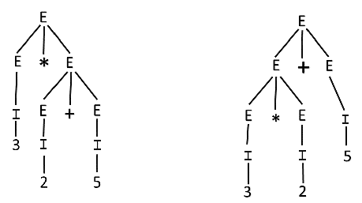
Since there are two parse trees for a single string "3 * 2 + 5", the grammar G is ambiguous.

Example 2:
Check whether the given grammar G is ambiguous or not.
- S → aSb | SS
- S → ε
Solution:
For the string "aabb" the above grammar can generate two parse trees
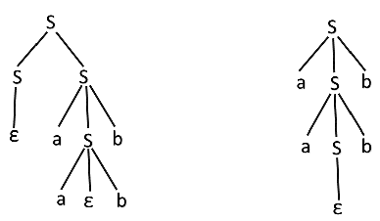
Since there are two parse trees for a single string "aabb", the grammar G is ambiguous.

